SIMATS ENGINEERING
ASSESSMENT TOOL 2

COURSE CODE: CSA14 COURSE NAME: Compiler Design

COURSE OUTCOME COVERED

CO1: Apply lexical analysis for token specification and recognition using LEX tool (BL3)

Assessment Tool Weightage: 20%

QUESTIONS: 3 Total Marks:50

Annexure A

ERROR ANALYSIS TASK

Code of Conduct:

I _E. Lakshmi Narayanan [192524249]_ certify that this submission is my original work and that I have adhered to the guidelines specified for this assessment.
I understand that any violation of academic integrity rules will result in disciplinary action.

Signature of the student: E. Lakshmi Narayanan

Annexure A

ERROR ANALYSIS TASK

Q1. The following program is intended to perform simple arithmetic operations, function calls, array access, and looping constructs. However, the code contains multiple errors introduced at different phases of compilation, including lexical, syntax, semantic, logical, and runtime errors.
Given Program
#include <stdio.h>

int sumArray(int arr[], int n) {
int i, sum = 0;
for(i = 0; i <= n; i++) {
sum = sum + arr[i];
}
return sum;
}

int main() {
int arr[5] = {1,2,3,4,5}
int total;

total = sumArray(arr);

if(total == 15) {
printf("Correct Sum\n")
}

int a = 10, b = 0;
int c = a / b;

int *p;
*p = 20;

return 0;
}
Tasks:
(a) Error Identification (Analysis Level)
- Identify all the errors present in the program. For each error:
- Specify the line number
- Clearly describe the nature of the error
(b) Classification of Errors (Understanding + Analysis)
- Classify each identified error into the appropriate compiler phase:
- Lexical Errors
- Syntax Errors
- Semantic Errors
- Logical Errors
- Runtime Errors
(c) Compilation Behavior (Evaluation Level)
- Analyze which errors will be detected during compilation and which will only appear during execution.
- Explain how early-stage errors (lexical/syntax) may prevent detection of later-stage errors.
(d) Code Correction (Application Level)
- Rewrite the corrected version of the program such that:
- All errors are removed
- The program executes correctly
- Proper syntax and semantics are maintained
(e) Impact Analysis (Evaluation Level)
- Discuss the impact of at least three errors on program execution.
- Explain how incorrect constructs like improper pointer usage, division by zero, and infinite loops affect system behavior.
(f) Advanced Compiler Perspective (Create Level)
- Suggest how a compiler can be improved to:
- Provide better error messages
- Perform early detection of runtime errors
- Propose at least two enhancements in compiler design for efficient debugging.

Q2.The following C program contains multiple lexical errors introduced intentionally. These errors occur due to invalid tokens, incorrect identifiers, malformed constants, and illegal symbols, which are typically detected during the lexical analysis phase of a compiler.Carefully examine the program and answer the questions given below.
#include <stdio.h>

int main() {
int 1num = 100;
float rate@ = 25.5;
char ch = 'abc';
int total = 50$20;
int num#1 = 30;
int %count = 40;

printf("Welcome to Compiler Design);

int x = 09;
int y = 0xZ12;
int z = 12.3.4;

char str1[] = "Hello;
char str2[] = "World";

int _valid = 10;
int invalid-id = 20;

float value = 5..6;
int data = 10@5;

char c = 'xy';
int 3value = 60;

printf("Value: %d\n", total);

return 0;
}
Tasks
(a) Error Identification
i) Identify all lexical errors in the program.
ii) List the line number and the invalid token.
(b) Error Classification
i) For each error, explain why it is considered a lexical error.
ii) Specify which rule of token formation is violated:
iii) Identifier rules
iv) Constant formation
v) String/character literal rules
vi) Operator/symbol rules
(c) Token Correction
i)Rewrite each invalid token into a valid token.
ii)Example: 2value → value2
(d) Compiler Behavior Analysis
i) Explain how a lexical analyzer (scanner) processes such errors.
ii)Discuss whether the compiler:
iii)Stops immediately
iv)Continues scanning using error recovery
(e) Advanced Thinking
i) Design a simple rule (or DFA idea) to detect invalid identifiers starting with digits.
ii) Suggest how error messages can be improved for beginners.
Q3. The following C program is designed to perform arithmetic operations, function calls, conditional checks, pointer usage, and looping. However, the program contains multiple errors distributed across different phases of a compiler, including:
- Lexical Errors
- Syntax Errors
- Semantic Errors
- Intermediate Code Generation Issues (logic/precedence)
- Code Optimization Issues (redundancy/inefficiency)
- Runtime / Target Code Errors
Carefully analyze the program and answer the questions below.

#include <stdio.h>

int divide(int a, int b) {
return a / b
}

int main() {
int #value = 20;
float num = 15.5
int result;

result = divide(10);

if(result = 5) {
printf("Result is 5\n")
}

int x = 10;
int y = 0;
int z = x / y;

int arr[4] = {1,2,3,4};
printf("%d\n", arr[4]);

int *ptr;
*ptr = 25;

int total;
total = x + y * result + 0;

while(x < 20) {
printf("%d\n", x);
}

return 0;
}
Do the following Tasks
(a) Identify Errors (Analysis Level)
- Identify all errors in the program.
- Mention line number + error description.

(b) Classify by Compiler Phase
Classify each error into:
- Lexical (invalid symbols like @num)
- Syntax (missing semicolon, brackets)
- Semantic (function argument mismatch)
- Intermediate Code Issues (wrong expression handling/precedence)
- Optimization Issues (redundant + 0)
- Runtime Errors (division by zero, invalid pointer access)

(c) Compilation vs Execution (Evaluation)
- Which errors are detected at compile time?
- Which errors appear only during execution?
- Explain why some errors prevent further compilation.

(d) Correct the Program (Application)
- Rewrite the fully corrected program.
- Ensure:
  - Proper syntax
  - Correct semantics
  - Safe execution

(e) Deep Analysis (Evaluation)
- Explain how incorrect pointer usage affects runtime.
- Analyze how array bounds violation impacts memory.
- Discuss how operator precedence errors affect intermediate code.

(f) Advanced Task (Create Level)
- Suggest 2 improvements in compiler design to:
  - Detect runtime errors earlier
  - Improve debugging messages
- Propose how optimization phase can remove redundant expressions.

Q1 (a) – Error Identification

Line | Error | Type | Description
51 | i <= n | Logical | It allows i = n, causing access outside the array.
58 | Missing ; | Syntax | A semicolon is required after the array declaration.
61 | sumArray(arr) | Semantic | The function requires two arguments, but only one is provided.
64 | Missing ; | Syntax | A semicolon is missing after the printf() statement.
68 | a / b where b = 0 | Runtime | Division by zero causes an error during execution.
71 | *p = 20 | Runtime | Pointer p is uninitialized and may access an invalid memory location.

Q1 (b) – Classification

Error Type | Errors
Lexical | No lexical error
Syntax | Lines 58, 64
Semantic | Line 61
Logical | Line 51
Runtime | Lines 68, 71

Q1 (c) – Compilation Behavior

Question | Answer
Compile-time errors | Syntax and semantic errors are detected during compilation.
Runtime errors | Division by zero, invalid pointer access and the out-of-bounds read caused by i <= n occur only during execution.
Effect of early errors | Lexical and syntax errors stop the compiler before semantic analysis and code generation, so later errors (such as the argument mismatch on line 61) may not be reported until the earlier ones are fixed.

CORRECTED PROGRAM

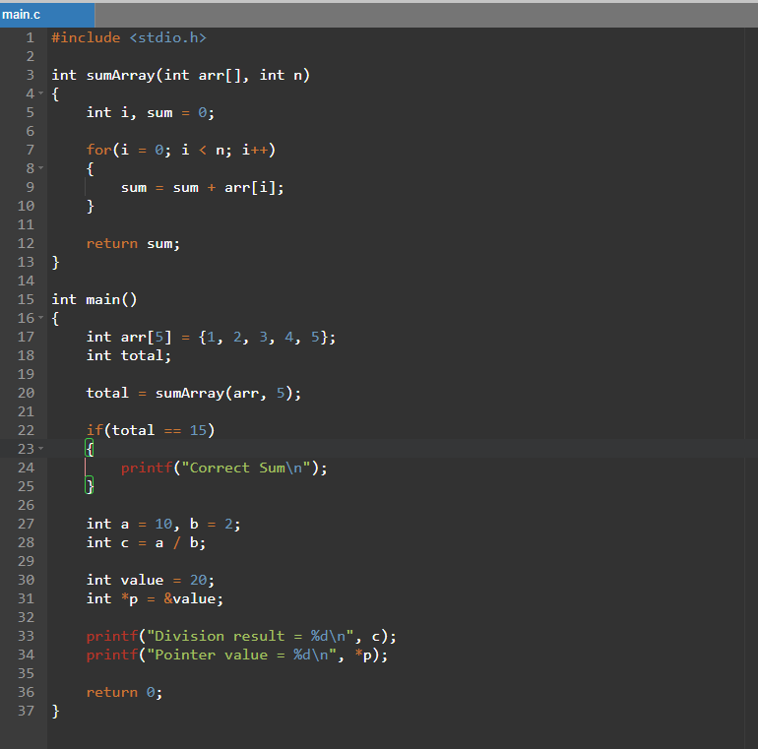

PROGRAM OUTPUT
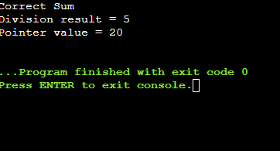

Changes made
- Added the missing semicolon after the array declaration.
- Passed 5 as the second argument to sumArray().
- Changed i <= n to i < n.
- Added the missing semicolon after printf().
- Changed b from 0 to 2 to avoid division by zero.
- Made pointer p point to a valid variable (int *p = &value;).
The corrected program now compiles and executes safely.

(e) Impact Analysis
1. Improper pointer usage
In:
int *p;
*p = 20;
p does not contain a valid address. Therefore, the program may try to write into an unknown memory location.
This can cause a segmentation fault, crash, or undefined behavior.

2. Division by zero
In:
int b = 0;
int c = a / b;
the program tries to divide a number by zero.
This is an invalid arithmetic operation and can terminate the program during execution.

3. Infinite loop
The program in Q1 does not contain an infinite loop, but an incorrectly written loop can easily create one.
For example:
while(x < 20)
{
printf("%d", x);
}
If x is never changed, the condition x < 20 remains true forever.
This keeps the CPU busy, the program never moves to the next statement, and it must be stopped manually.

(f) Advanced Compiler Perspective
A compiler can be improved in several ways to make debugging easier.
1. Better error messages
Instead of simply saying:
Syntax error
the compiler can say:
Line 58: Missing semicolon ';' after array declaration.
This makes it much easier for beginners to understand and correct the problem.
2. Early detection
The compiler can use static analysis to identify possible problems such as:
- Division by zero
- Uninitialized pointers
- Possible array out-of-bounds access
- Unused variables
before the program is executed.
3. Better debugging support
A compiler can provide:
- Exact line numbers
- Suggested corrections
- Warnings for suspicious code
- Variable information during debugging
These features can save a lot of time while finding errors.

Q2 (a–c) – Error Identification, Rule Violated and Correction
Line | Invalid Token | Rule Violated | Correction
130 | 1num | Identifier rule: an identifier cannot start with a digit. | num1
131 | rate@ | Identifier rule: @ is not allowed in an identifier. | rate
132 | 'abc' | Character literal rule: a character literal must contain exactly one character. | 'a'
133 | 50$20 | Operator/symbol rule: $ is not a valid symbol in C. | 50+20
134 | num#1 | Identifier rule: # is not allowed in an identifier. | num1
135 | %count | Identifier rule: an identifier cannot start with %, which is an operator symbol. | count
137 | "Welcome to Compiler Design | String literal rule: the closing quotation mark is missing. | "Welcome to Compiler Design"
139 | 09 | Constant formation: 9 is not a valid digit in an octal constant (leading 0). | 9
140 | 0xZ12 | Constant formation: Z is not a hexadecimal digit. | 0x12
141 | 12.3.4 | Constant formation: a numeric constant cannot contain two decimal points. | 12.34
143 | "Hello | String literal rule: the closing quotation mark is missing. | "Hello"
147 | invalid-id | Identifier rule: - is not allowed in an identifier (it is read as the minus operator). | invalid_id
149 | 5..6 | Constant formation: a floating constant cannot contain two decimal points. | 5.6
150 | 10@5 | Operator/symbol rule: @ is not a valid arithmetic operator. | 10+5
152 | 'xy' | Character literal rule: a character literal must contain exactly one character. | 'x'
153 | 3value | Identifier rule: an identifier cannot start with a digit. | value3

Q2 (d) – Compiler Behavior

Point | Answer
Lexical analyzer | Reads characters and groups them into valid tokens.
Invalid token | The scanner reports a lexical error when a character sequence does not match a token rule.
Error recovery | A compiler normally does not stop at the first lexical error. It reports the error, skips the invalid characters (panic-mode recovery) and continues scanning so that more errors are found in one run.

Q2 (e) – DFA Idea
Rule: An identifier must begin with a letter or _, followed by letters, digits or _.
START → letter/_ → VALID IDENTIFIER
START → digit → INVALID
Better error message:
Line 153: '3value' is invalid because an identifier cannot start with a digit.

Q3 (a) – Error Identification

Line | Error | Type | Description
198 | Missing ; | Syntax | Semicolon is required after return a / b.
202 | #value | Lexical | # is not allowed in a normal identifier.
203 | Missing ; | Syntax | Semicolon is missing after 15.5.
206 | divide(10) | Semantic | divide() requires two arguments but only one is given.
208 | result = 5 | Logical | = assigns a value; == should be used for comparison.
209 | Missing ; | Syntax | Semicolon is missing after printf().
214 | x / y, y = 0 | Runtime | Division by zero occurs during execution.
219 | arr[4] | Runtime | Index 4 is outside the valid range 0–3.
222 | *ptr = 25 | Runtime | Pointer is uninitialized and may access invalid memory.
225 | + 0 | Optimization | Adding zero is unnecessary and can be removed.
225 | x + y * result | Intermediate code | Multiplication has higher precedence than addition, so it is evaluated as x + (y * result); a wrong grouping gives a wrong value.
227–230 | No change to x | Logical/Runtime | x < 20 remains true, creating an infinite loop.

Q3 (b) – Classification

Category | Lines
Lexical | 202
Syntax | 198, 203, 209
Semantic | 206
Logical | 208, 227–230
Optimization | 225
Intermediate code | 225
Runtime | 214, 219, 222

Q3 (c) – Compilation vs Execution

Type | Errors
Compile-time | Lexical, syntax and semantic errors
Runtime | Division by zero, invalid pointer and array access, infinite loop
Early-stage effect | Syntax/lexical errors can prevent later compiler phases from processing the program correctly.

CORRECTED PROGRAM

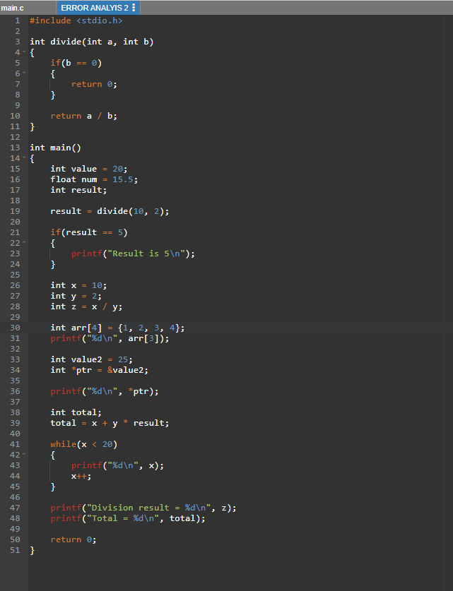

PROGRAM OUTPUT

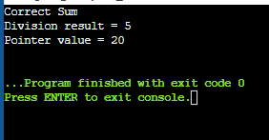

(e) Deep Analysis
Pointer usage: An uninitialized pointer holds a garbage address, so writing through it may overwrite unrelated memory or access a protected region, causing a segmentation fault, undefined behavior or a crash.
Array bounds: arr[4] is invalid for an array of size 4 because the valid indexes are only 0 to 3. C does not check array bounds, so the access touches memory just beyond the array: a read returns a garbage value, while a write can corrupt neighbouring variables or crash the program.
Operator precedence: In x + y * result, multiplication has higher precedence, so it is evaluated first and the expression is treated as x + (y * result). The intermediate code is generated in that order; if (x + y) * result was intended, the program silently produces a wrong value with no error message.

(f) Compiler Improvements
A compiler can use static analysis to detect possible runtime problems such as division by zero, unsafe pointers and array-bound violations before execution.
It can improve debugging by displaying the exact line, cause of the error and a possible correction.
During optimization, redundant expressions such as + 0 can be removed to make the generated code simpler and more efficient.

RUBRICS FOR CALCULATION:

Criteria | Weightage | Level 4 (Exemplary) | Level 3 (Proficient) | Level 2 (Developing) | Level 1 (Beginning)
Error Identification | 20% | Accurately identifies all errors with clear understanding of issues | Identifies most errors with minor omissions | Identifies limited errors; some are missed | Fails to identify key errors
Root Cause Analysis | 30% | Clearly explains underlying causes with strong technical reasoning | Explains causes with moderate clarity | Partial explanation; weak reasoning | Unable to identify causes of errors
Correction & Justification | 25% | Provides correct solutions with strong justification and logic | Provides correct corrections with some justification | Corrections are partially correct or weakly justified | Incorrect or no corrections provided
Application of Concepts | 15% | Effectively applies relevant concepts to analyze and resolve errors | Applies concepts with minor errors | Limited application; requires guidance | Unable to apply concepts
Clarity & Presentation | 10% | Presents analysis clearly, logically, and systematically | Generally clear with minor issues | Lacks clarity or proper structure | Poor presentation and difficult to understand

